**Course-End Project :** Web Application Deployment Using Ansible

**Objective**

To create an automation script to deploy an application using Ansible and Jinja2 template

**Problem Statement and Motivation**

Real-time scenario:

You have joined as a DevOps engineer in XYZ Pvt. Ltd. It is a platform where individuals can create their profile and start blogging on various topics. The application is ready to be hosted on a server.

You are tasked with implementing an Ansible script to deploy this application on a remote Nginx server.

**Industry Relevance**

The following tools used in this project serve specific purposes within the industry:

1.Ansible: Ansible automates IT tasks, streamlining configuration management, application deployment, and orchestration. It uses simple, human-readable YAML files called playbooks, allowing easy setup and management of complex IT environments.

**Tasks**

The following tasks outline the process of deploying web application on a remote server:

1.Create an inventory file to define the remote server(s)

[webserver]

54.86.245.130

Create ansible.cfg

[defaults]

Inventory = /home/ansiuser/cep1inventory





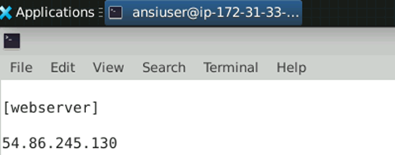

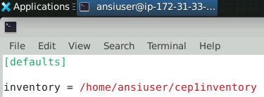

2.Write a YAML playbook with tasks for installing Nginx, copying web application files, deploying the Nginx configuration, and enabling the site

playbookNginx.yml

- name: Deploy on nginx

hosts: webserver

become: true

vars:

http_port: 80

document_root: /var/www/html

tasks:

- name: Install nginx

package: name=nginx state=present

- name: Start Nginx

service: name=nginx state=started

- name: update nginx conf

template: src=default.j2 dest=/etc/nginx/sites-available/default

notify: Restart nginx service

- name: Copy the index.html file

copy: src=index.html dest=/var/www/html

handlers:

- name: Restart nginx service

service: name=nginx state=restarted



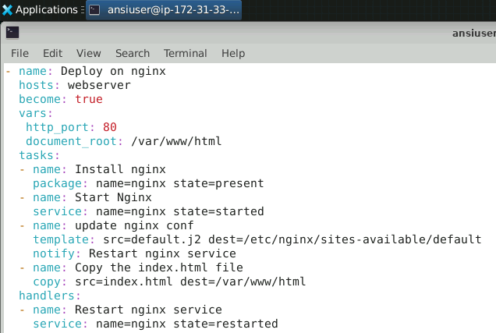

3.Create a directory for templates and a Jinja2 template for the Nginx configuration

Default.j2 source code

server {

listen {{ http_port }};

listen [::]:{{ http_port }};

root {{ document_root }};

index index.html index.htm;

server_name _;

location / {

try_files $uri $uri/ =404;

}

}



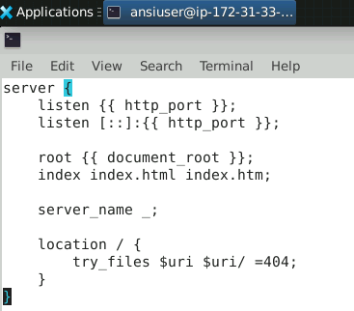

4.Define variables in the playbook for application details and Nginx configuration

Playbooknginx source code in task 1



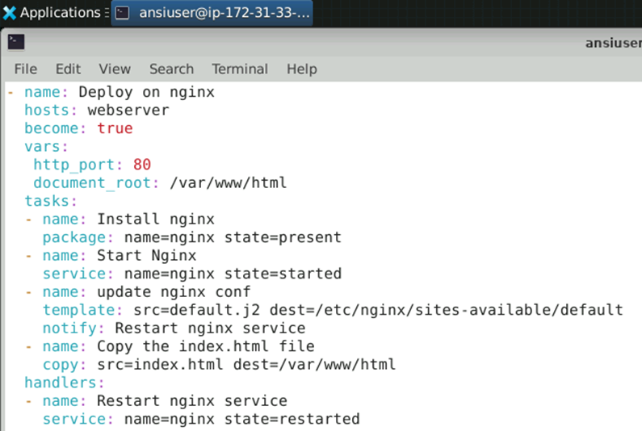

5.Include tasks in the playbook for installing Nginx, copying application files, deploying Nginx configuration, and enabling the Nginx site

Playbooknginx source code in task 1



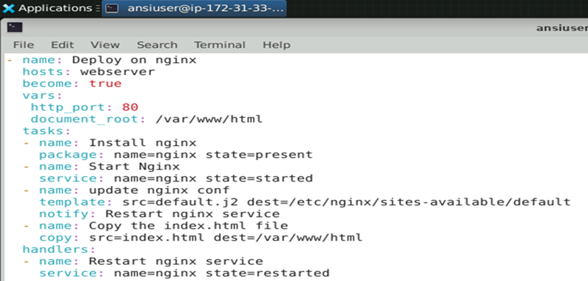

Index.html source code:

<!DOCTYPE html>

<html lang="en">

<head>

<meta charset="UTF-8">

<title>Sammy the Shark's Site</title>

<style>

body {

background-color: #d0f0f7; /* light ocean blue */

font-family: 'Segoe UI', Tahoma, Geneva, Verdana, sans-serif;

margin: 0;

padding: 0;

text-align: center;

color: #003f5c;

}

header {

padding: 40px 0;

background-color: #90e0ef;

}

h1 {

font-size: 3em;

margin-bottom: 0.2em;

}

h2 {

font-size: 2em;

margin-top: 0;

color: #0077b6;

}

.marquee {

font-size: 1.3em;

color: #0077b6;

margin: 20px 0;

}

.content {

padding: 40px 20px;

}

.footer {

margin-top: 40px;

font-size: 1em;

color: #5e6472;

}

img {

max-width: 300px;

margin: 20px auto;

}

</style>

</head>

<body>

<header>

<div class="marquee">

<marquee behavior="scroll" direction="left">Welcome to Sammy the Shark's Awesome Site!</marquee>

</div>

<h1>Sammy the Shark</h1>

<h2>Learning to Swim Through the Web 🌊</h2>

</header>

<div class="content">

<img src="https://www.digitalocean.com/_next/static/media/DO_Sammy.f4a3e13d.svg" alt="Sammy the Shark">

<p>This site was deployed using <strong>Ansible</strong> on an <strong>AWS EC2</strong> instance.</p>

<p><strong>Created by:</strong> Phillip Moleke</p>

<p><strong>Project:</strong> Course-End Project — Configuration Management with Ansible and Terraform</p>

</div>

<div class="footer">

&copy; 2025 Sammy the Shark | Powered by NGINX & Ansible

</div>

</body>

</html>



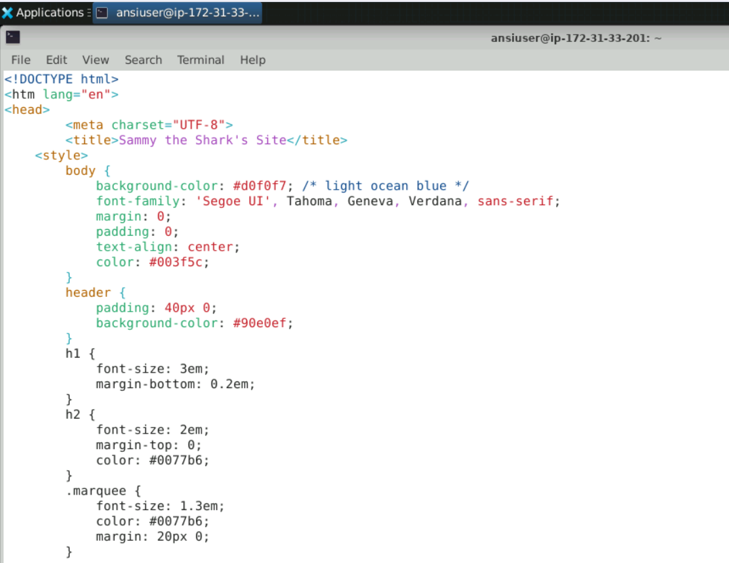

6.Execute the playbook to deploy the web application on the remote server



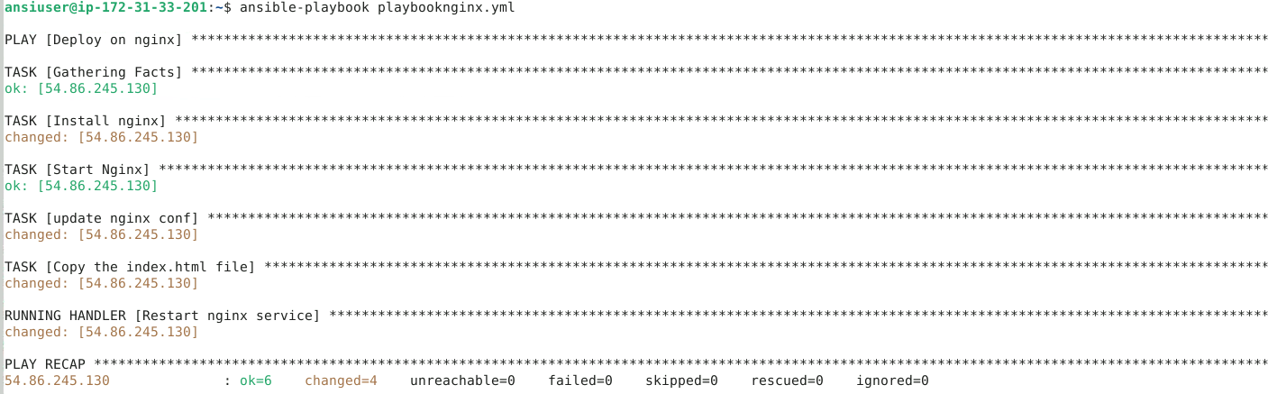

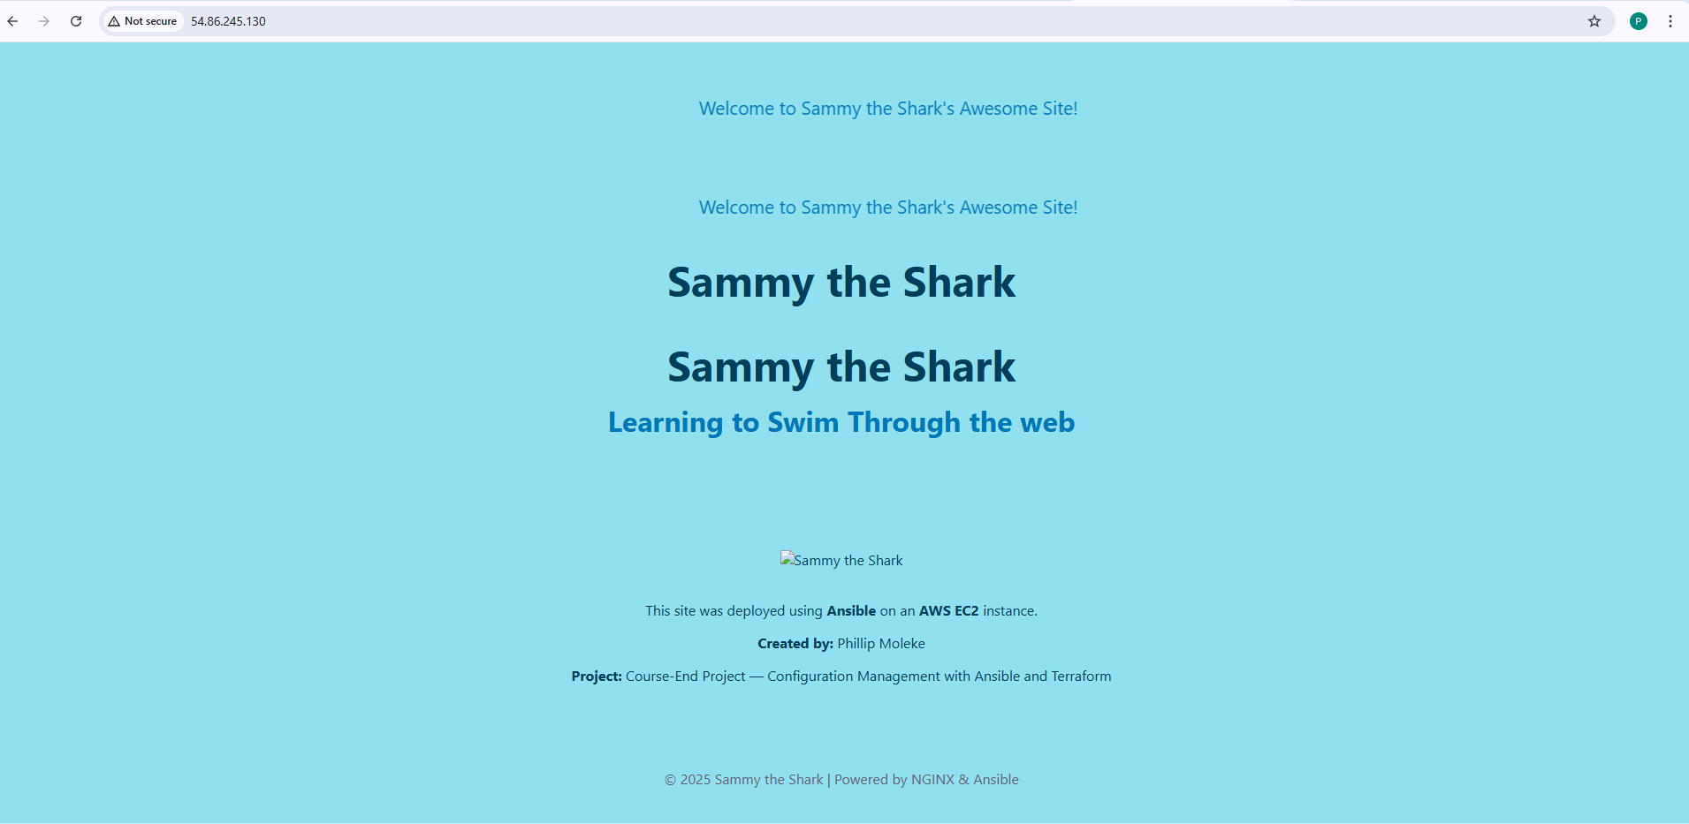

Done.

Thank you

Prepared by : Phillip Tshegofatso Moleke

Date: April 2025